**Initial Configuration on Watsonx**

Create First Project

Once you have logged in, ensure you are in watsonx platform (not Cloud Pak for Data) as you see below.

If you are in Cloud Pak for Data, click icon on top-right corner and select IBM watsonx.



Go to Projects section and click plus icon



Give name to your project, ensure Storage field is ”CloudObjectStorage” and click Create button.

Go to Manage tab 🡪 Services & integration 🡪 click Associate service button.

Select Watson Machine Learning to associate this service then click Associate button. Now you will be able to use watsonx.ai service (jupyter notebook, prompt template, and deployment space).

Create First Deployment Space

Now click Hamburger icon on top-left corner 🡪 select Deployments 🡪 click Deployment space button.

Give name to your new deployment space 🡪 select CloudObjectStorage on storage service field 🡪 select WatsonMachineLearning on machine learning service field 🡪 click Create button.

You will use this to deploy your prompt or any functions later in the next sessions.

Get IBM Cloud API Key

Go to https://cloud.ibm.com/login (login using your credentials if neccessary) 🡪 click Manage on top row 🡪 Access (IAM).

Click API Keys on left pane 🡪 click Create button.

Give name to your new API key and click Create button.

Once it is created, you need to download and store somewhere in your local directory. Starting from now, you will be able to connect to watsonx service using 3rd party application.

Create First Bot using Watsonx Assistant

Now click Hamburger icon on top-left corner and select Resource List.

Type “watsonx assistant” on Name search field until you have found watsonx assistant service. Then click it.

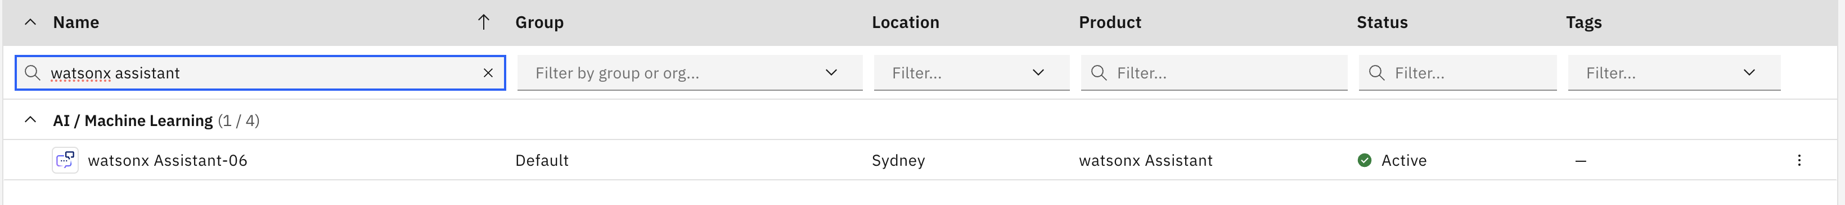

Ensure you have access to the instance by clicking Launch watsonx Assistant button.

When you have access, you need to setup your first bot. Please give the name then click Next button.

Fill the description of your bot with your preference, you can use sample below. After filling all of the required fields (Deployment Location, Industry, Role, and Statement), click Next button.

Watsonx Assistant gives flexibility to customize front end UI, you can skip this step for now to use default UI template. Click Next button.

You also can see the preview of watsonx assistant when it is embedded on 3rd party website. Click Next Create button.

You can use this bot for your activities in next sessions.

Now you are ready to onboard on watsonx incubation. Happy exploring!